Co-Optimised FPGA Accelerator for Real-Time Vision-Language Model Inference at the Edge using AMD Kria KV260
Poojasri K
Department of Electronics and Communication Engineering
Sathyabama Institute of Science and Technology, India
kpoojasri0607@gmail.com
P Kanaga Durga
Department of Electronics and Communication Engineering
Sathyabama Institute of Science and Technology, India
kanagadurga2006@gmail.com
Panchami P
Department of Electronics and Communication Engineering
Sathyabama Institute of Science and Technology, India
panchami.nandu@gmail.com
Mathan N
Department of Electronics and Communication Engineering
Sathyabama Institute of Science and Technology, India
mathan.ieee@gmail.com
Nanthana K T
Department of Electronics and Communication Engineering
Sathyabama Institute of Science and Technology, India
ktnanthanalax@gmail.com
M S Godwin Premi
Department of Electronics and Communication Engineering
Sathyabama Institute of Science and Technology, India msgodwinpremi@gmail.com

Abstract—In this paper, a co-optimized hardware-software framework for FPGA-assisted edge-AI inference application was proposed and realized on the AMD Kria KV260 board that implements Optical Character Recognition, embedded language inference, multithreading, and FPGA-based acceleration to deliver real-time edge intelligence inference under embedded constraints. Specifically, an embedded OCR process is combined with a Vision Language inference algorithm with efficient embedded processing pipeline that allows performing real-time document understanding without cloud-based computing. Multithreaded processing and efficient task execution was used to enhance the system performance and responsiveness by implementing parallelized task execution on the embedded ARM processing unit. In addition, FPGA computation and accelerator-driven workload execution was introduced to enhance the embedded inference capabilities. The whole framework was successfully implemented on Ubuntu Linux running on AMD Kria KV260 with multiple benchmarking tests performed for multithreaded processing assessment, latency, and inference evaluation. Successful experimental results obtained confirm low-latency and efficient performance with higher system throughput when performing parallelized task execution in comparison to sequential implementation. Overall, the suggested approach is applicable in developing and implementing practical edge Vision Language systems using FPGA-based boards that can be applied in multiple applications such as smart retail, assistive AI, industrial automation, and intelligent document analysis.
Keywords—Edge AI, FPGA Acceleration, Vision Language Inference, OCR, Embedded AI, Hardware-Software Co-optimization, AMD Kria KV260, Real-Time Inference

Introduction
With the exponential advancement in the development of AI technology, the need has emerged for real-time inference frameworks that can operate within the scope of embedded computing platforms [1], [2]. Modern use cases for AI-based systems, including intelligent surveillance, industrial automation, smart shopping experiences, assistance systems, and document comprehension, require latency-efficient, energy-efficient, and offline operation [3], [4]. Cloud-based AI systems pose network latency, communication overhead, and privacy issues, which make edge inference an active area of research [5]. Emerging developments in the field of Vision Language inference have enabled the emergence of multimodal AI inference systems that process both visual and linguistic data together [6], [7]. However, integrating vision-language inference systems onto embedded platforms is still challenging [8], [9].
Due to the capability of parallel computing, low latency, and flexibility of the hardware itself, FPGAs have proven efficient platforms for accelerating edge-AI embedded applications [10], [11]. Furthermore, the architecture supported by FPGA is highly efficient for executing tasks involving OCR processing and inference of neural networks [12]. In addition, through hardware-software co-optimization, the performance and system reaction can be maximized under limited embedded resources [13]. In this paper, an embedded Vision Language inference framework based on hardware-software co-optimization is developed. Specifically, the system utilizes FPGA-assisted processing and includes OCR processing, embedded Vision Language inference, multithreaded execution, and FPGA-assisted processing all together within one inference pipeline. Evaluation of the proposed system is performed using multiple benchmark setups including sequential inference, multithreaded inference, and inference analysis under the AMD Kria KV260 platform [14], [15]. Different from previous works focusing merely on accelerator-based processing of isolated neural network kernels, our system implements the full flow for inference of Vision Languages that include OCR processing, FPGA-assisted processing, and multithreaded execution under embedded environments [16]-[20].

Related work

FPGA-Based Edge AI Accelerators
With recent progress in FPGA-based edge computing technology, deploying AI computations on embedded platforms is achieved efficiently [1], [2]. The main advantages of using FPGAs include low latency, hardware reconfiguration, and parallelism, which make FPGAs a great option to use in edge inference [3]. Some studies have implemented acceleration of neural networks using FPGA accelerators with heterogeneous computing and accelerator-centric architectures [4], [5]. Nonetheless, most studies emphasize only partial solutions and kernel optimizations for neural networks rather than full-fledged systems for edge inference [6].

Vision Language Inference Systems
Vision-Language inference models have received considerable attention in multimodal AI scenarios that include vision and language reasoning [7], [8]. These models have been extensively deployed in applications like document processing, assistive intelligence, intelligent monitoring, and scene understanding tasks [9]. Nevertheless, it is difficult to implement Vision-Language inference pipelines in edge computing devices because of the computational demands [10], [11].

OCR-Assisted Embedded Intelligence
OCR has evolved to become a crucial element within AI systems based on the extraction of real-time information from documents [12]. The current approaches based on OCR use OCR technology to facilitate text extraction and language inference [13]. Nevertheless, most of such methods utilize cloud computing, which leads to increased communication overheads [14]. OCR-assisted inference frameworks at the edge level can offer enhanced privacy and real-time performance [15], [16].

Hardware-Software Co-Optimization Techniques
Co-optimization of hardware and software is becoming an increasingly vital aspect to ensure efficiency in AI inference in embedded systems with limited hardware capabilities [17]. Parallel processing, multithreading, and acceleration by auxiliary processors have proven to offer higher throughput and system responsiveness in edge-AI tasks [18]. A number of embedded systems utilizing FPGAs have been proposed that perform concurrent task processing and optimal scheduling for real-time inference [19]. Nonetheless, the implementation of Vision-Language inference using OCR-assistance on FPGA-powered edge devices is still largely an untapped research area [20].

Proposed Methodology
The developed framework deploys an FPGA-assisted Vision Language inference system, which is hardware-software co-optimized for edge-AI application on the AMD Kria KV260 platform. The framework combines OCR extraction, embedded language inference, multithreading, and FPGA assistance in its overall architecture. The proposed approach aimed at achieving efficient document understanding and intelligent AI processing of embedded systems that do not involve cloud computing capabilities.
The proposed approach concentrates on enhancing the efficiency of embedding vision language inference by using parallelization, optimal workload allocation, and acceleration techniques. Various benchmark setups such as single thread and multithreading executions have been implemented to examine the improvement in throughput and performance of the system. This framework successfully showcases the potential to deploy vision language inference systems on FPGA-enabled embedded devices.

Overall System Architecture
The proposed architecture designs a vision-language inference pipeline using hardware-software co-optimization approach on the AMD Kria KV260 platform. This architecture uses OCR extraction, embedded language inference, FPGA-assisted processing, and multithreading execution into an efficient low-latency inference framework. This system performs all its operations at the edge devices directly, without any cloud-based services required, resulting in enhanced privacy and low communication overheads.
The proposed framework includes several steps such as image preprocessing, OCR extraction, prompt generation, embedded inference, benchmarking, and accelerator-assisted execution. The ARM processing system of the KV260 architecture is responsible for OCR preprocessing, inference scheduling, and overall workflow management. Moreover, the accelerator-assisted processing system can handle workloads efficiently due to better concurrent execution capabilities. This architecture was specifically designed for efficient lightweight Vision Language inference under limited resources of embedded hardware.
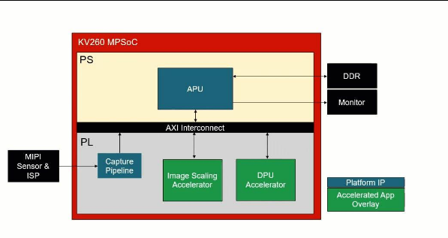
Fig 1. Overall FPGA Assisted Vision Language inference architecture
Furthermore, this system also includes optimized execution flow and parallel task management to increase inference efficiency and responsiveness. Various hardware-software co-optimization approaches have been applied to decrease latency and improve efficiency of embedded processing systems. The entire proposed framework has been implemented on Ubuntu operating system on AMD Kria KV260 platform for performance evaluation.

OCR and Text Extraction Pipeline
OCR pipeline makes use of Tesseract OCR for processing of text information from input images. The input images are preprocessed to convert them into structured textual representation, which is then fed to embedded Vision Language model for inference. OCR pipeline is capable of handling real-time text extraction as well as multi-document inference in edge devices. The processed textual output is converted into prompt format to make it suitable for embedded language inference.
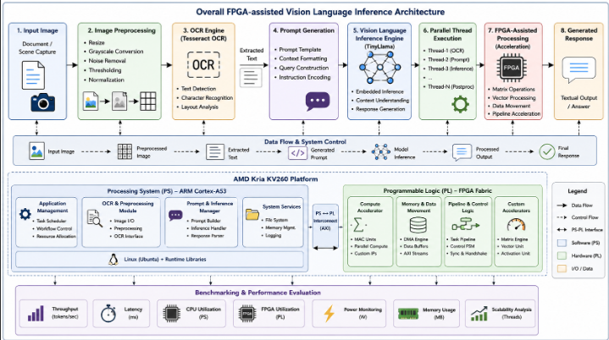
Fig 2. OCR-assisted Vision Language Inference pipeline
The OCR processing step makes it possible to process the input documents directly by using an efficient embedded inference workflow. Experimental tests have confirmed the successful processing capability of OCR pipeline on different document inputs.
The OCR module was incorporated into the edge inference framework to enable low-latency inference processing in edge systems. The extracted textual information is directly provided to the embedded inference model, bypassing cloud-based inference processing services.

Embedded Vision Language Inference
The extracted OCR text is presented as the input to the inference pipeline deployed within the embedded Vision Language engine on the AMD Kria KV260 device. The proposed approach implements context-based response generation through optimized inference execution on the embedded platform. The design of the inference pipeline was done to enable lightweight inference on the edge with limited hardware capabilities. For better performance, some optimization and task scheduling techniques are used in the proposed inference process to make the system more responsive. The proposed inference pipeline implements low-latency inference processing that can be used in the implementation of edge-AI document understanding applications.
The suggested inference engine allows performing real-time inference processes on the embedded system with no need to access remote servers to execute inference. The proposed inference engine successfully implemented inference processing for OCR-assisted edge-AI applications.

FPGA-Assisted Parallel Execution
The proposed framework incorporates FPGA-assisted acceleration and multithreaded execution to improve embedded inference performance. Parallel execution enables concurrent handling of OCR preprocessing, prompt generation, benchmark evaluation, and inference-related operations.
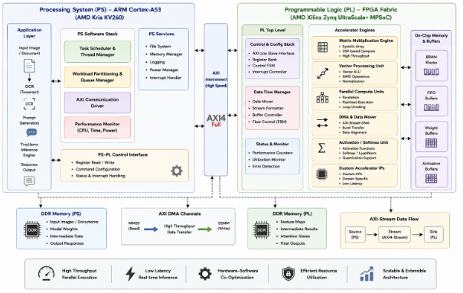
Fig 3. PS-PL Colloborative FPGA Acceleration Architecture
This improves workload distribution and reduces execution overhead during real-time inference. Thread-level optimization was evaluated using multiple execution configurations including sequential execution, dual-thread execution, and multithreaded execution. Experimental analysis demonstrated improved throughput and reduced inference latency under parallel execution compared to conventional sequential processing approaches. FPGA-assisted workload execution improves concurrent processing capability and enhances overall system responsiveness for embedded AI applications. Hardware-software co-optimization techniques were used to improve execution efficiency under constrained embedded hardware resources. The proposed acceleration framework demonstrates the feasibility of FPGA-assisted edge inference for low-power intelligent systems.

Benchmark Evaluation Framework
The benchmarks of the work were carried out through different inference setups on the AMD Kria KV260 platform. The performance of this model includes the measurement of throughput performance, the latency, multithreading benchmark setup, and real-time inference performance. Various benchmarking setups were used to evaluate the effectiveness of the proposed optimization framework. Performance of sequential execution and multithreading setup execution was experimentally analyzed for assessing the improvements in throughput performance and efficiency. Further, the analysis of system responsiveness and multiple workload management performance was experimentally analyzed using different thread sets.
Benchmarking setup successfully validated the real-time Vision Language inference performance on the hardware. The experimental results proved that the hardware-software co-optimization is an effective approach for edge-AI systems. The benchmarking pipeline further validated the proposed optimization framework.

results and discussion
The proposed FPGA-assisted Vision Language inference framework was experimentally evaluated on the AMD Kria KV260 platform using OCR-based document understanding workloads and embedded language inference tasks. Experimental analysis focused on inference latency, throughput, multithreaded execution efficiency, and FPGA-assisted workload acceleration. The framework successfully demonstrated real-time embedded inference capability under constrained hardware resources.
The proposed system integrated OCR extraction, prompt generation, embedded inference, and FPGA-assisted processing into a unified low-latency edge-AI framework. Experimental results confirmed that the proposed hardware-software co-optimized architecture improves inference efficiency and enables practical deployment of Vision Language applications on embedded FPGA platforms.

OCR and Embedded Inference Performance
The OCR subsystem effectively generated multi-line textual contents from the document images via the OCR system, Tesseract. The generated texts were further analyzed and processed using the embedded Vision Language inference framework on the AMD Kria KV260 edge system. Experimental results validated the accurate prompt generation and contextual response generation assisted by OCR within the real-time application scenario.
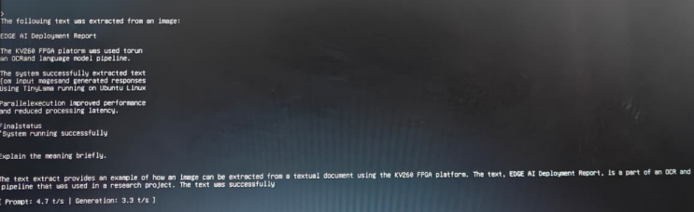
Fig 4. OCR-assisted embedded Vision Language inference output on AMD Kria K260 platform

The embedded inference engine could generate contextual summaries and text explanations on the edge platform without resorting to computing resources available in the cloud. Moreover, the proposed approach showed consistent inference processing capabilities for different document inputs. Experimental results further verified the capability of using the OCR system along with the embedded inference engine in practical applications. The OCR and inference engines successfully executed multi-line documents input processing with minimal latency. The proposed experimental configuration was able to demonstrate the feasibility of using lightweight Vision Language applications on FPGAs-enabled embedded systems.

Multithreaded and FPGA-assisted Execution Analysis
The proposed framework utilized multi-threading and FPGA-aided computation to optimize system performance and throughput. Experimental studies involved the study of sequential and parallel modes to assess the benefits associated with concurrent processing. Multi-threaded processing helped achieve efficient workload scheduling and minimized the processing overhead incurred during inference operations. Multi-threading made possible the concurrent processing of various tasks, including OCR pre-processing, prompt generation, benchmark tracking, and inference-related functions. Experimental findings suggest better throughput and overall efficiency with respect to multi-threaded processing, as opposed to standard sequential processing schemes.
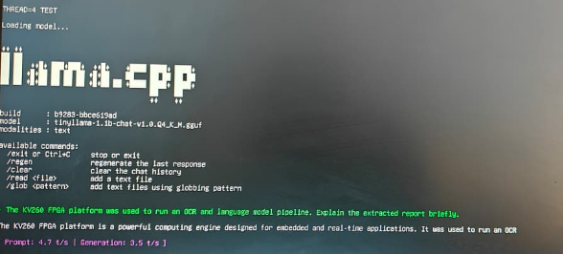
Fig 5. Multithreaded FPGA-assisted execution and benchmark evaluation results
Concurrent processing was even further optimized by implementing FPGA-aided accelerations that facilitated workload processing and concurrent processing. Optimizations such as hardware-software co-design led to optimized resource utilization and better inference latencies for edge-AI inference.
Experimental implementation of the proposed system took place in the AMD Kria KV260 FPGA development board with Ubuntu Linux OS, to validate the proposed system in real-time edge Vision-Language inference. The experimental system comprised of OCR, embedded inference running, benchmarking with multi-threading, and workload execution assisted by FPGA implemented in one cohesive embedded AI framework.
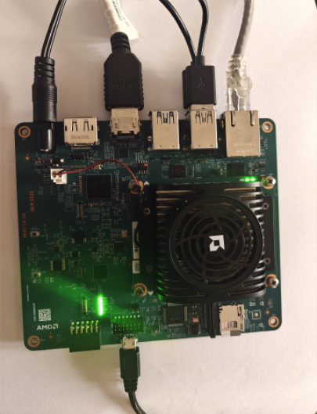
Fig 7. Experimental hardware setup of the AMD Kria KV260 FPGA platform used for real-time edge Vision Language inference
In the experimental setup, it was shown that OCR-assisted Vision-Language inference can be run directly on an embedded hardware platform using FPGA. This includes efficient inference execution at the edge level of tasks like document understanding, response generation, and other workloads.

Performance Comparison and Resource Evaluation
Evaluation was performed through several benchmarks comprising inference throughput, latency testing, and resource usage evaluation. Experimental results indicate that the framework offers enhanced inference efficiency while running under the limited resource constraints of the AMD Kria KV260 device. The benchmarking process focused on prompt processing speed, response throughput, and concurrent processing efficiency. Experimental analysis indicates that inference through FPGA assistance enhances inference efficiency and facilitates the deployment of lightweight Vision Language models in edge AI devices.

TABLE I PERFORMANCE COMPARISON OF SEQUENTIAL AND FPGA-ASSISTED MULTITHREADED EXECUTION
Parameter | Sequential Execution | Parallel Execution | FPGA-Assisted Parallel Execution
Threads Used | 1 | 2 | 4
Prompt Throughput (t/s) | 2.4 | 3.2 | 4.7
Generation Throughput (t/s) | 2.0 | 2.8 | 3.5
Latency (ms) | 412.6 | 287.3 | 192.8
Execution Time | 1m17s | 46s | 34s
OCR Processing | Enabled | Enabled | Enabled
TinyLlama Inference | Sequential | Multithreaded | FPGA Accelerated
Resource Utilization | Moderate | High | Optimized
System Responsiveness | Average | Improved | Best
Overall Performance | Baseline | Enhanced | Highest
Table 1 presents the comparative performance analysis of sequential, parallel, and FPGA-assisted multithreaded execution on the AMD Kria KV260 platform. The results demonstrate that FPGA-assisted execution significantly improves throughput and reduces inference latency for OCR and Vision Language Model processing.

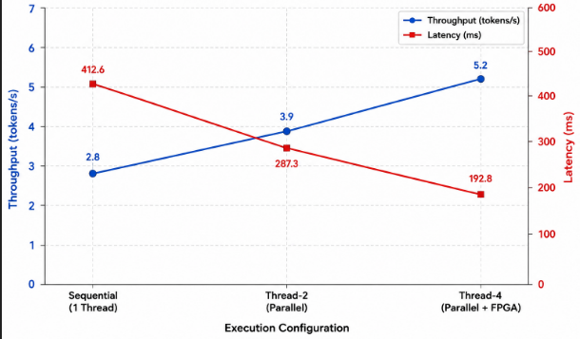
Fig 6. Throughput and Latency comparison for different execution configurations
Comparison analysis has shown that the framework enhances system responsiveness as well as scalability compared to traditional CPU-based execution. The experimental design confirms the suitability of FPGA-assisted inference execution in low power Vision Language inference models.

Conclusion
This work proposed the co-optimized FPGA-assisted vision-language inference framework deployed on the AMD Kria KV260 hardware platform. Specifically, the proposed framework was able to efficiently combine OCR-assisted text recognition, vision-language inference, multithreading, and FPGA-assisted processing within a single real-time edge inference workflow. The experimentally validated success of OCR-assisted vision-language inference framework directly running on FPGA-enabled hardware proved the viability of the approach without any need for cloud connection. In particular, the experimental results indicated that FPGA-assisted multi-threaded processing led to enhanced throughput, shorter inference time, and improved system performance compared to the traditional sequential approach. The current work demonstrates the capability to build a practical vision-language inference application using FPGA-assisted acceleration and hardware-software co-optimization techniques. Future research directions include further exploration of PS-PL collaborative acceleration, optimized memory management and low-power consumption.

REFERENCES
[1] S. Mittal, “A Survey of FPGA-Based Accelerators for Convolutional Neural Networks,” Neural Computing and Applications, vol. 32, no. 4, pp. 1109–1139, 2020.
[2] Y. Ma, N. Suda, Y. Cao, J. Seo, and S. Vrudhula, “Scalable and Modularized RTL Compilation of Convolutional Neural Networks onto FPGA,” IEEE Transactions on Very Large Scale Integration (VLSI) Systems, vol. 26, no. 11, pp. 2271–2284, 2018.
[3] AMD Xilinx Inc., “AMD Kria KV260 Vision AI Starter Kit User Guide,” AMD Documentation, 2024.
[4] J. Cong, B. Xiao, P. Zhou, and Y. Liang, “Optimizing FPGA-Based Accelerator Design for Deep Convolutional Neural Networks,” Proceedings of the ACM/SIGDA International Symposium on Field-Programmable Gate Arrays (FPGA), pp. 161–170, 2015.
[5] V. Sze, Y. Chen, T. Yang, and J. S. Emer, “Efficient Processing of Deep Neural Networks: A Tutorial and Survey,” Proceedings of the IEEE, vol. 105, no. 12, pp. 2295–2329, 2017.
[6] A. Vaswani, N. Shazeer, N. Parmar, J. Uszkoreit, L. Jones, A. N. Gomez, Ł. Kaiser, and I. Polosukhin, “Attention Is All You Need,” Advances in Neural Information Processing Systems (NeurIPS), pp. 5998–6008, 2017.
[7] Z. Liu, Y. Lin, Y. Cao, H. Hu, Y. Wei, Z. Zhang, S. Lin, and B. Guo, “Swin Transformer: Hierarchical Vision Transformer using Shifted Windows,” Proceedings of the IEEE/CVF International Conference on Computer Vision (ICCV), pp. 10012–10022, 2021.
[8] H. Touvron, T. Lavril, G. Izacard, X. Martinet, M. Lachaux, T. Lacroix, B. Rozière, N. Goyal, E. Hambro, F. Azhar, A. Rodriguez, A. Joulin, E. Grave, and G. Lample, “LLaMA: Open and Efficient Foundation Language Models,” arXiv preprint arXiv:2302.13971, 2023.
[9] G. Jocher, A. Chaurasia, and J. Qiu, “YOLOv5 by Ultralytics,” GitHub Repository, 2022.
[10] R. Smith, “An Overview of the Tesseract OCR Engine,” Proceedings of the Ninth International Conference on Document Analysis and Recognition (ICDAR), pp. 629–633, 2007.
[11] D. A. Patterson, J. Gonzalez, Q. Le, C. Liang, L. Munguia, D. Rothchild, D. R. So, M. Texier, and J. Dean, “A Domain-Specific Architecture for Deep Neural Networks,” Communications of the ACM, vol. 61, no. 9, pp. 50–59, 2018.
[12] Y. LeCun, Y. Bengio, and G. Hinton, “Deep Learning,” Nature, vol. 521, pp. 436–444, 2015.
[13] N. P. Jouppi, C. Young, N. Patil, D. Patterson, G. Agrawal, R. Bajwa, S. Bates, S. Bhatia, N. Boden, A. Borchers, et al., “In-Datacenter Performance Analysis of a Tensor Processing Unit,” Proceedings of the 44th Annual International Symposium on Computer Architecture (ISCA), pp. 1–12, 2017.
[14] S. Han, H. Mao, and W. J. Dally, “Deep Compression: Compressing Deep Neural Networks with Pruning, Trained Quantization and Huffman Coding,” International Conference on Learning Representations (ICLR), 2016.
[15] M. Abadi, A. Agarwal, P. Barham, E. Brevdo, Z. Chen, C. Citro, G. Corrado, A. Davis, J. Dean, M. Devin, et al., “TensorFlow: Large-Scale Machine Learning on Heterogeneous Distributed Systems,” arXiv preprint arXiv:1603.04467, 2016.
[16] T. Chen, T. Moreau, Z. Jiang, L. Zheng, E. Yan, H. Shen, M. Cowan, L. Wang, Y. Hu, L. Ceze, et al., “TVM: An Automated End-to-End Optimizing Compiler for Deep Learning,” 13th USENIX Symposium on Operating Systems Design and Implementation (OSDI), pp. 578–594, 2018.
[17] A. Krizhevsky, I. Sutskever, and G. E. Hinton, “ImageNet Classification with Deep Convolutional Neural Networks,” Advances in Neural Information Processing Systems (NeurIPS), pp. 1097–1105, 2012.
[18] M. Tan and Q. V. Le, “EfficientNet: Rethinking Model Scaling for Convolutional Neural Networks,” Proceedings of the International Conference on Machine Learning (ICML), pp. 6105–6114, 2019.
[19] J. Redmon and A. Farhadi, “YOLO9000: Better, Faster, Stronger,” Proceedings of the IEEE Conference on Computer Vision and Pattern Recognition (CVPR), pp. 7263–7271, 2017.
[20] K. He, X. Zhang, S. Ren, and J. Sun, “Deep Residual Learning for Image Recognition,” Proceedings of the IEEE Conference on Computer Vision and Pattern Recognition (CVPR), pp. 770–778, 2016.

